Student ID: BC080400090
Name: Asif Ashraf

Question # 1

Consider a computer network with 8 devices, in this network each device is directly connected with each other through a twisted pair cable. Calculate the number of links required to connect these devices with each other and fill in the following table.

This is mesh Topology:
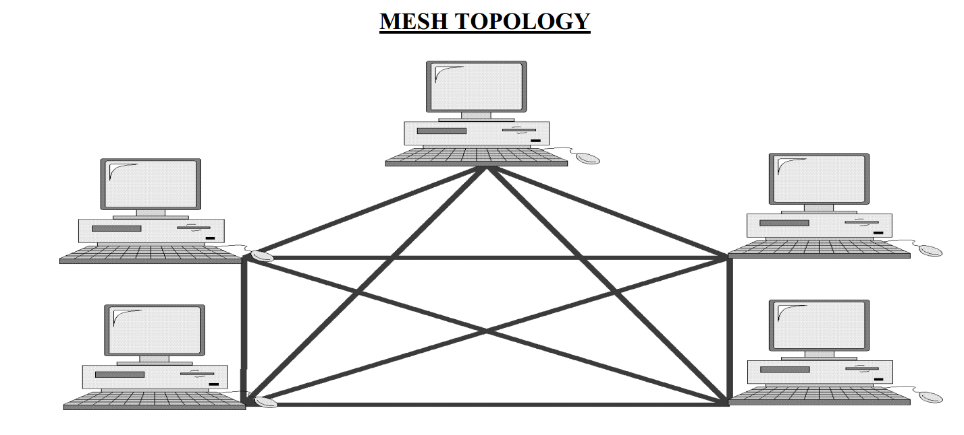

To calculate links we will use formula
# of links = n(n-1)/2

n = node
substituting n with 8
# of links = 8(8-1)/2
# of links = 8(7)/2
# of links = 56/2
# of links = 28

Question No. 2

Identify the type of transmission mode for each of the following cases:

Case | Transmission Mode
Monitoring through Surveillance Camera | Simplex
Talking through Walkie-talkie | Half duplex (since only one man speaks at a time)
Phone call through smart Cell phone | Full duplex
Watching a broadcast Television | Simplex
Real time high speed Audio-Video Conferencing | Full duplex

